PM-eco Series | UWE

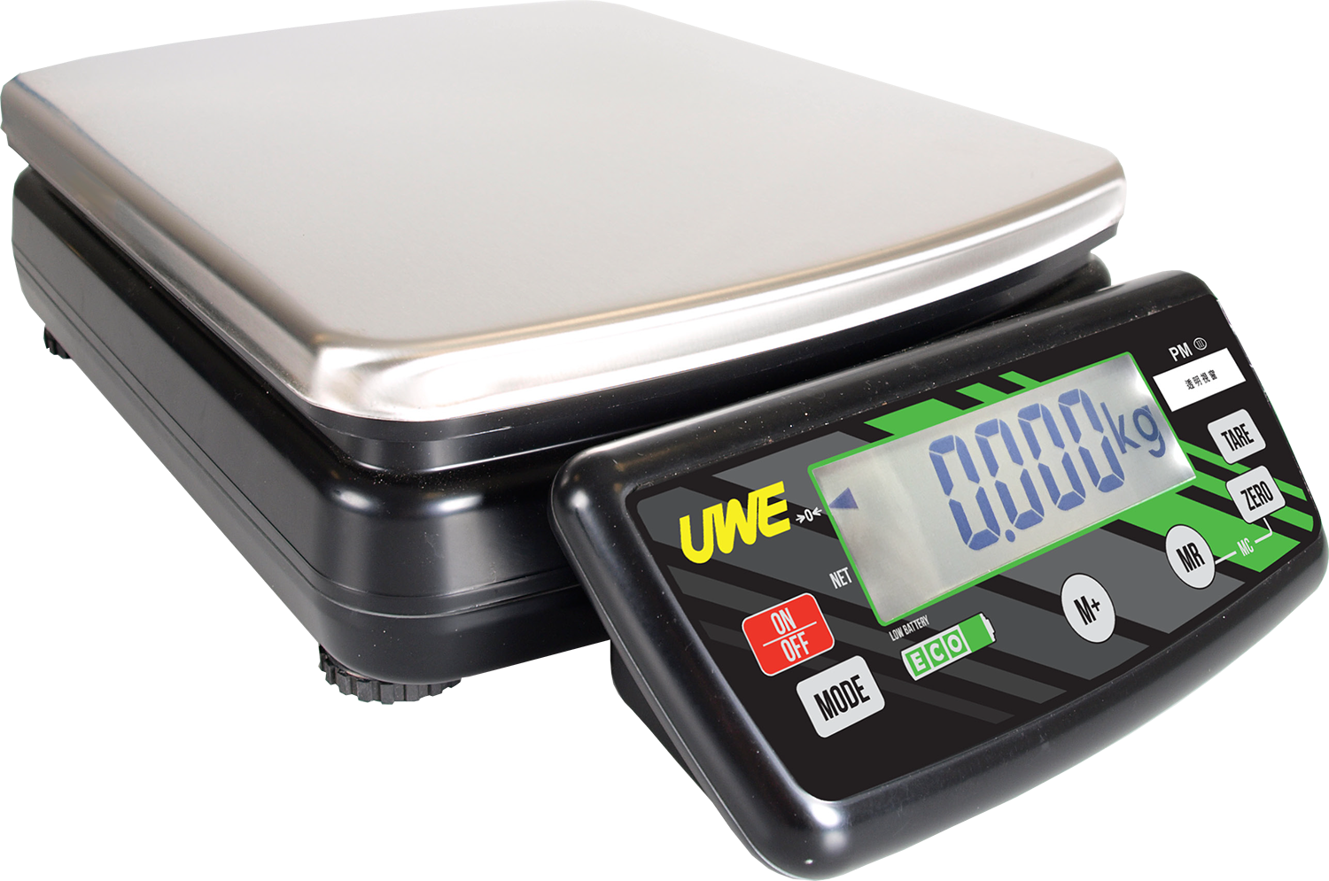 | - All Year Battery (Up To 3500 Hours)  - Accumulation  - Strong, Light and Adaptable  - Lightweight and Portable  - Backlight Display  - Economical  - Removable Indicator  - 3 Size-D Dry Cell Batteries included  - Optional adaptor  - Made in Taiwan  - Platform Size: 280 x 330 mm

PM ECO-30 | 30 kg | 5 g

